**Add Two Dimensions in Webtrends**

1. Insert code in web page you want to monitor and give two parameters:

dcsMultiTrack('DCSext.A','xxx','DCSext.B','xxx’);

1. Create two dimensions with parameter A and B
2. In custom report – tab dimension, choose one for primary dimension and one for secondary dimension

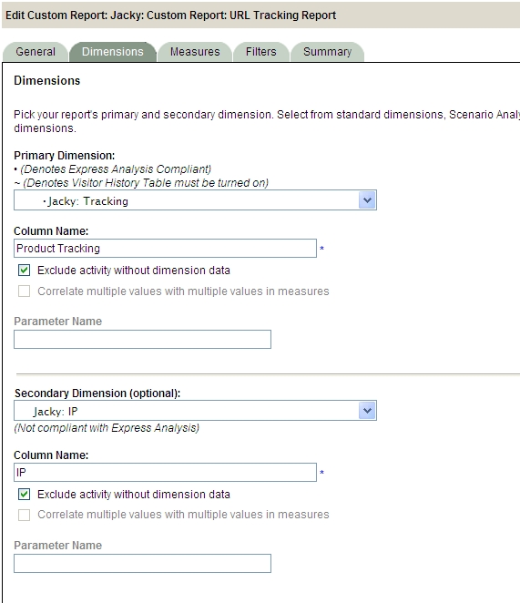

1. Here is the result

